**Sri Sivasubramaniya Nadar College of Engineering**

**Data analytics**

**Assignment 1**

**The case of 50 Start Ups**

**Names:** Naveen Raj E

**Roll Nos.:** SSNCE193002066

**Branch:** Electronics and Communication Engineering

1. **Column Plot:**

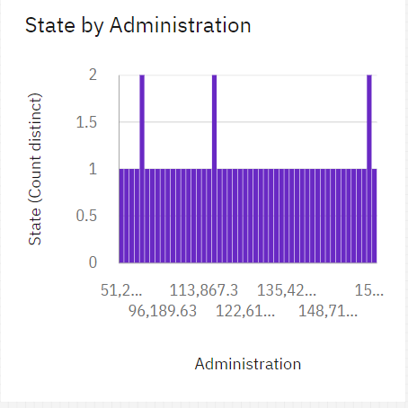

1. **Line Plot:**

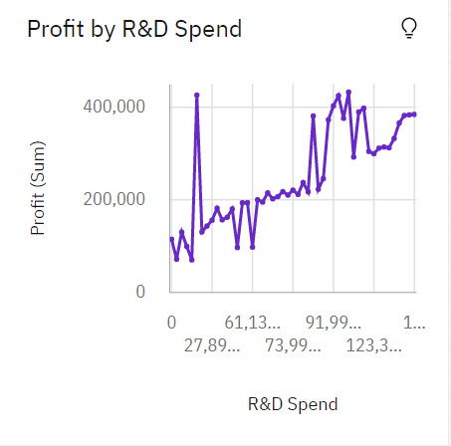

1. **Radial Plot:**

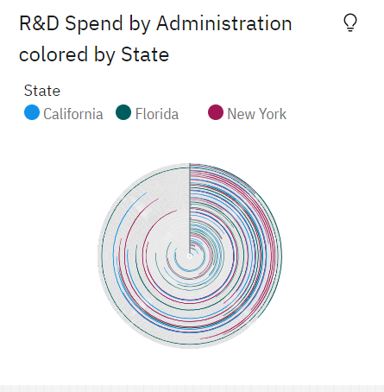

1. **Spiral Plot:**

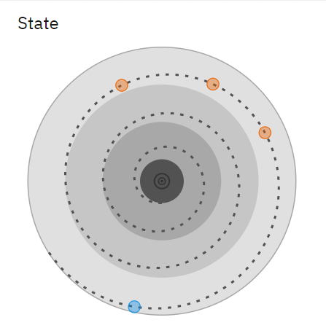

1. **Scatter Plot:**

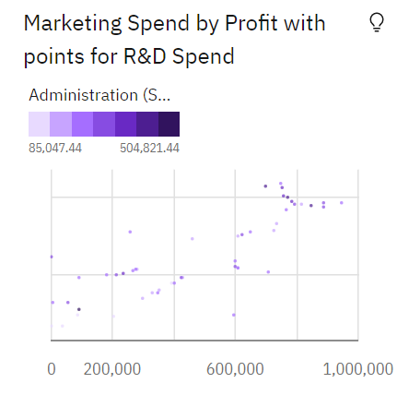

1. **Pie Chart:**

